Experiment No : 4
Title :
Use Function Types, Scope, and Closures; Apply Try-Catch for Error Handling; Build a Palindrome Checker and a Timer-Based Case Study Using setTimeout and setInterval
Software/Tools Required :
- Visual Studio Code (or any text editor)
- Web Browser (Google Chrome, Microsoft Edge, Mozilla Firefox, etc.)
- Basic knowledge of HTML, CSS, and JavaScript

Theory :
JavaScript offers multiple ways to define reusable blocks of logic, along with rules that determine where a variable can be accessed and mechanisms to handle runtime errors gracefully. This experiment covers function types, scope, closures, error handling using try-catch, and JavaScript's timer functions.
1. Function Types
- Function Declaration — defined using the function keyword with a name; it is hoisted, so it can be called before its definition in the code.
- Function Expression — a function assigned to a variable; it is not hoisted and can be named or anonymous.
- Arrow Function — a shorter syntax introduced in ES6 using =>; it does not have its own this binding and is commonly used for concise, single-purpose functions.
Example:
function reverseNumber(num) { /* named function declaration */ }
const isPalindrome = (num) => { /* arrow function expression */ };
2. Scope
- Global Scope — variables declared outside any function or block; accessible from anywhere in the script.
- Function (Local) Scope — variables declared inside a function are accessible only within that function.
- Block Scope — variables declared with let or const inside {} are accessible only within that block.
3. Closures
A closure is formed when a function 'remembers' the variables from its outer (enclosing) scope even after that outer function has finished executing. Closures are commonly used to create private variables that persist across multiple function calls without relying on global variables.
Example: A counter function defined inside an outer function keeps its own private count variable, which stays intact between calls but is inaccessible from outside.
4. Try-Catch (Error Handling)
The try-catch statement allows a program to handle runtime errors without crashing. Code that might fail is placed inside the try block; if an error occurs, control passes to the catch block, where it can be handled or displayed to the user.
- Simple try-catch — wraps a risky operation and catches any thrown error.
- Try-catch inside if — validation logic combined with conditional checks before processing continues.
- Try-catch with a custom function — a validation function throws a custom Error object using throw, which is then caught by the calling code.
Example:
try { if (isNaN(value)) { throw new Error('Not a number'); } } catch (err) { console.log(err.message); }
5. setTimeout() and setInterval()
- setTimeout(function, delay) — executes a function once, after a specified delay (in milliseconds).
- setInterval(function, delay) — repeatedly executes a function at a fixed time interval, until stopped.
- clearTimeout() / clearInterval() — cancel a pending timeout or a running interval using the ID returned when it was created.
These are used to build time-based, asynchronous behaviour such as countdowns, reminders, and live-updating UI elements.

Aim of CASE STUDY 1 : Palindrome Checker (Number)
To write a function that reverses a given number and uses it to check whether the number is a palindrome, demonstrating function types, loops, and basic error handling through an interactive webpage.
Working of the System :
The user enters a number and clicks 'Check'. After validating the input with try-catch, reverseNumber() reverses the digits using a while loop, and the result is compared to the original to display whether it's a palindrome.

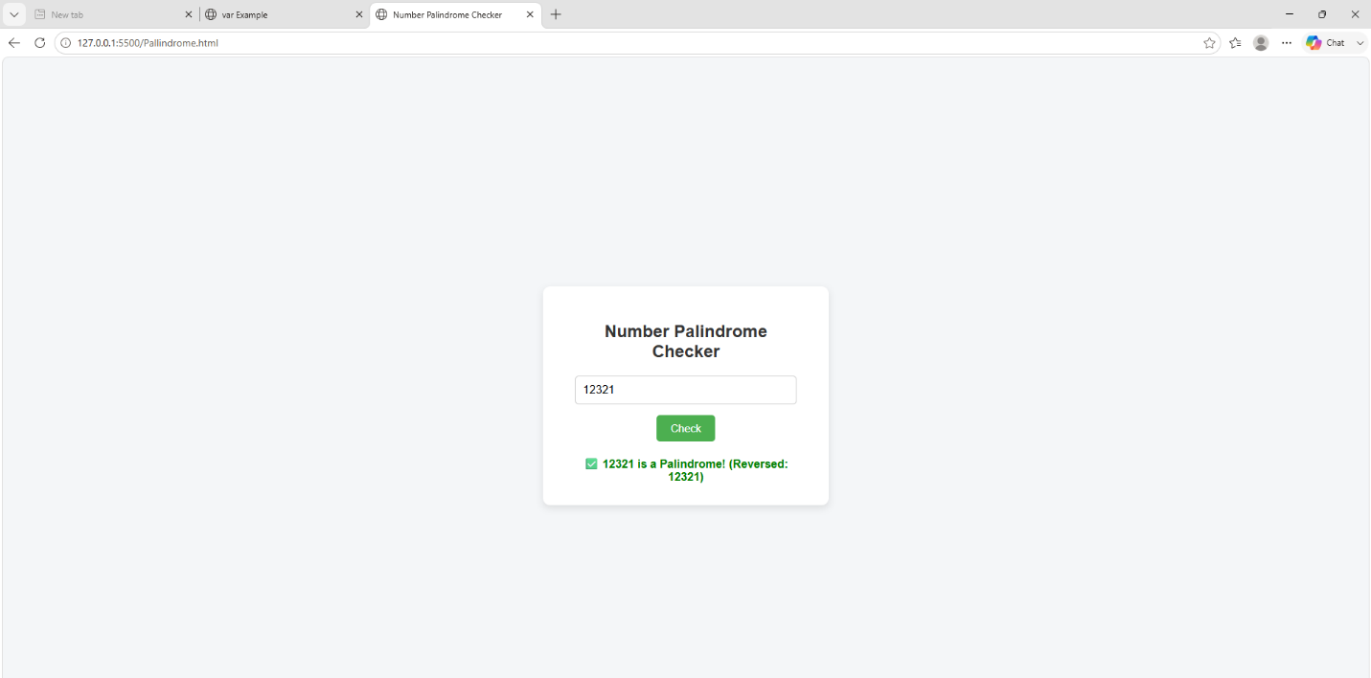

Aim of CASE STUDY 2 : Insta vs Study Time Tracker
To simulate a productivity tool where the user sets a time limit for Instagram use, and once that time elapses, an alert reminds them to switch to studying — built to practice setTimeout, setInterval, closures, and try-catch.
Working of the System :
The user enters a time limit and clicks 'Start'; setInterval updates a live countdown while setTimeout fires an alert once the time is up, switching the UI into study mode. A closure keeps a private reminder count, and cancelTimer() clears both timers to stop or restart.

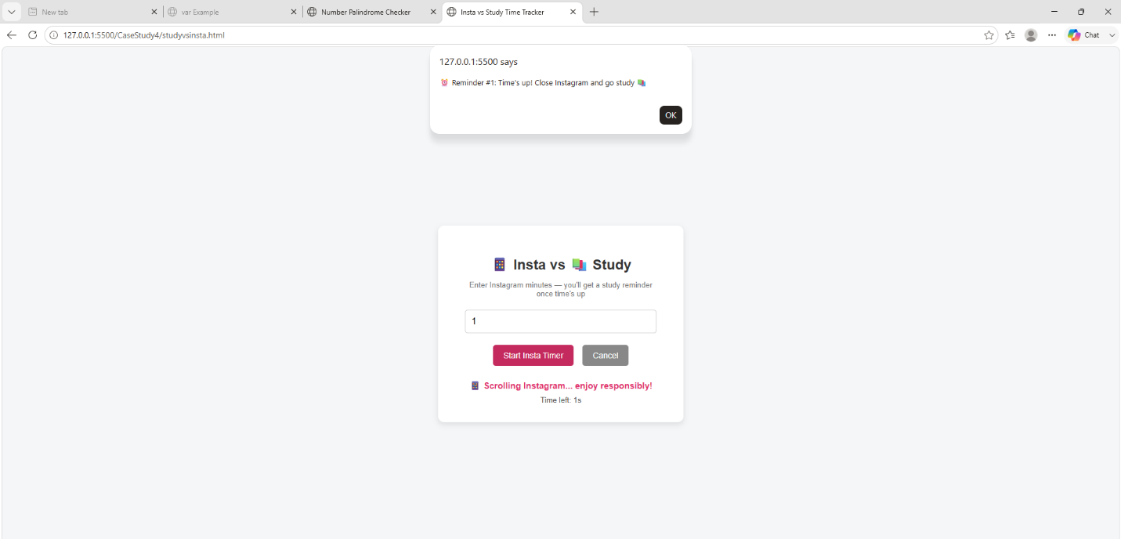

Name : Sumira Wandile PRN : 24070521275
File path "C:\Users\ASUS\OneDrive\Desktop\symbi\Sem 5\JavaScript\Practical 4"

Result/Conclusion :
This experiment demonstrated the use of different function types (declaration, expression, and arrow functions), variable scope, and closures in JavaScript, along with error handling using try-catch in multiple forms — a simple try-catch, try-catch combined with conditional checks, and try-catch used with a custom validation function that throws an Error. A numeric palindrome checker was built to apply these concepts using a while loop and DOM updates, and an Insta vs Study Time Tracker was built to practice asynchronous, time-based programming using setTimeout, setInterval, and closures. Together, these case studies provided practical understanding of function design, error handling, and timer-based interactivity in real-world web applications.

